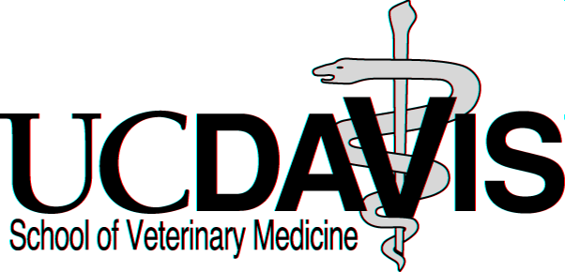

Application Statistics for the Class of 2010

Applicant Pool Summary:
Applied Offered Accepted Applied Accepted
Admission Offer
Residency: Gender:
California Residents: 514 131 125 Female: 776 103
WICHE Residents: 75 2 1 Male: 190 28
Nonresidents: 377 6 5 Total: 966 131
Total Applicants: 966 139 131

Admitted Applicant Statistics:

- Average GPA’s: Accumulative (3.42), Required Science (3.28), Last 45 semester units (3.55)

- Average GRE scores: Verbal (75% - 574 scaled score), Quantitative (70% - 702),
Analytical Writing (67% - 5.0)

- Average Age: 26 (age range 19-41)

- Ethnicity: African American/Black (1), Asian/Other Asian (13), Caucasian (78), Hispanic/Mexican American/Other Spanish (14), Multi-Ethnic (3), Decline to state (22)

- Primary Undergraduate College: UCD (46), UC (29), CSU (20), other CA (6), out-of state (30)

- Undergraduate Majors: Animal-Related Sciences (41), Biological Sciences (67),
Natural/Environmental Sciences (3), Other (20 humanities, business, etc.)

- Undergraduate Degrees: B.A. (26), B.S. (99), No degree (6)

- Advanced Degrees: M.A/M.S. (10), PhD (2)

- Years of College Education at Application: 2 yrs (3), 3 yrs (16), 4 yrs (56), 5 yrs (30), over 5 (26)

- Average Number of Veterinary-Related Experience Hours at Application: 3,550

- Applicants Admitted on 1st Application (82), 2nd (34), 3rd (9), 4th or more (6)

- Areas of Veterinary Interest at Application: small animal (43), equine (25), mixed (7),
wildlife (8), large (7), lab animal (6), small/equine (6), research (11), avian/exotics (5), food (6),
zoo (3), academics/teaching (4)

Undergraduate Colleges of Admitted Students
(Majority of undergraduate academic work)

University of California: Out-of-State Colleges:
Admitted Applied
UC Berkeley 6 17 Amherst College, MA 1
UC Davis 46 160 Ben Gurion University, Israel 1
UC Irvine 1 11 Brown University, RI 2
UC Los Angeles 7 22 Carleton College, MN 1
UC Riverside 1 6 Cornell University, NY 1
UC San Diego 6 25 Doshisha University, Japan 1
UC Santa Barbara 2 17 Harvard University, MA 1
UC Santa Cruz 6 14 Monash University, Australia 1
Total: 75 272 New Mexico State University 1
Northwestern University, IL 1
Princeton University, NJ 1
Smith College, MA 1
California State Universities: University of Arizona 1
Admitted Applied University of Huddersfield, UK 1
CSU, Bakersfield 0 1 University of Maryland 2
CSU, Chico 1 4 University of Massachusetts 1
CSU, Dominguz Hills 0 1 University of Montana 1
CSU, East Bay 0 3 University of North Carolina 2
CSU, Fresno 1 4 University of Puget Sound, WA 1
CSU, Fullerton 0 2 University of Washington 2
Humboldt State 1 5 University of Wisconsin 1
CSU Long Beach 0 10 Virginia Polytechnic Institute 1
CSU Los Angeles 0 1 Wake Forest University, NC 1
CSU, Monterey Bay 1 1 Washington State University 1
CSU, Northridge 2 8 Worcester Polytechnic Institute 1
CSPU, Pomona 3 32 Yale University, CT 1 CSU, Sacramento 0 5 Total: 30
San Diego State 2 6
San Francisco State 0 6
San Jose State 0 1
CSU San Marcos 1 2
CPSU San Luis Obispo 8 41
Sonoma State 0 1
CSU, Stanislaus 0 1
Total: 20 135

Other California Colleges:
Pomona College 1
Santa Clara University 1
Stanford University 2
University of Southern CA 1
Westmont College 1
Total 6

J:admiss/statistics and profiles

